Sumama Rahim
F24BSCS039
Database systems Lab 05 Task Report

Name | Sumama Rahim | Course | Database Systems (CSC-103) | Dprtt/ Program | IET - BSCS
Registration | F24BSCS039 | Instructor | Dr. M. Bilal Shahnawaz | Date | 04/18/2025

Lab 05 Task Report

Problem: Write a report to show the applied queries and their responses.

Solution:
Query 1. Apply all of the character and string functions and report the output
-- Changing case --
SELECT *, UPPER(Employee_Name) AS 'UPPER CASED'
FROM Employee;

Response:

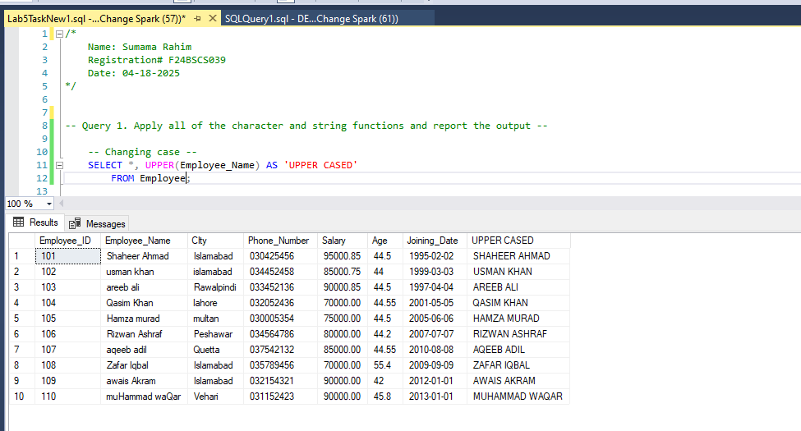
Query:

SELECT *, UPPER(City) AS 'UPPER CASED'
FROM Employee;
Response:
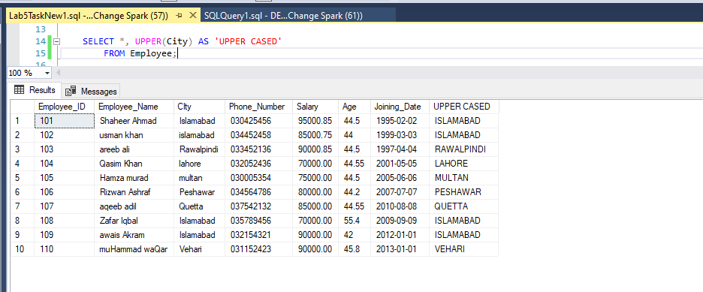
Query:
SELECT *, LOWER(Employee_Name) AS 'lower cased'
FROM Employee;
Response:
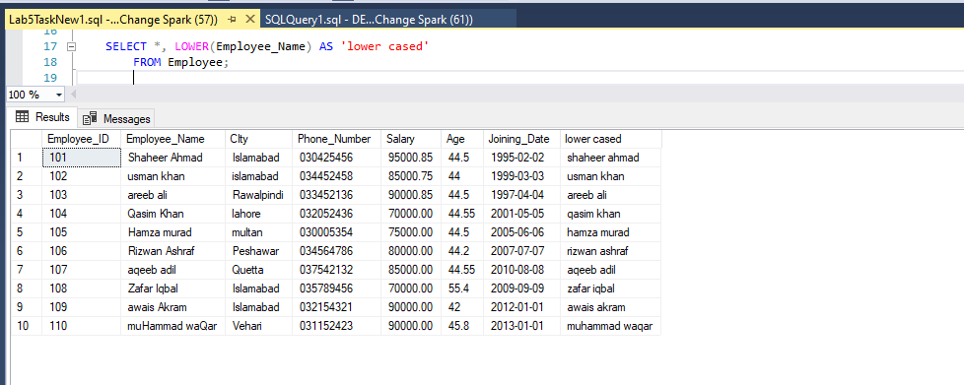

Query:
SELECT *, LOWER(City) AS 'lower cased'
FROM Employee;
Response:
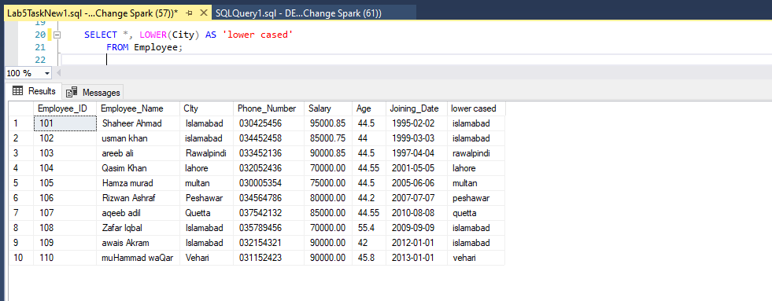
Query:
SELECT *, UPPER(LEFT(Employee_Name, 1))+
LOWER(SUBSTRING(Employee_Name, 2 , LEN(Employee_Name))) AS 'First Letter Cap'
FROM Employee;
Response:
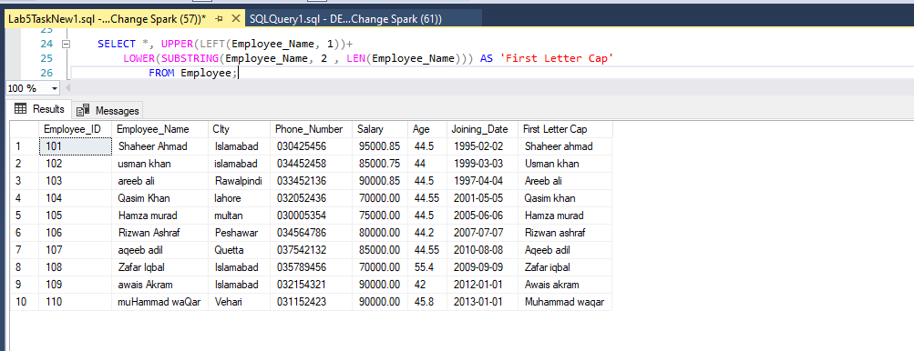
Query:
SELECT *, UPPER(LEFT(City, 1))+
LOWER(SUBSTRING(City, 2 , LEN(City))) AS 'First Letter Cap'
FROM Employee;
Response:
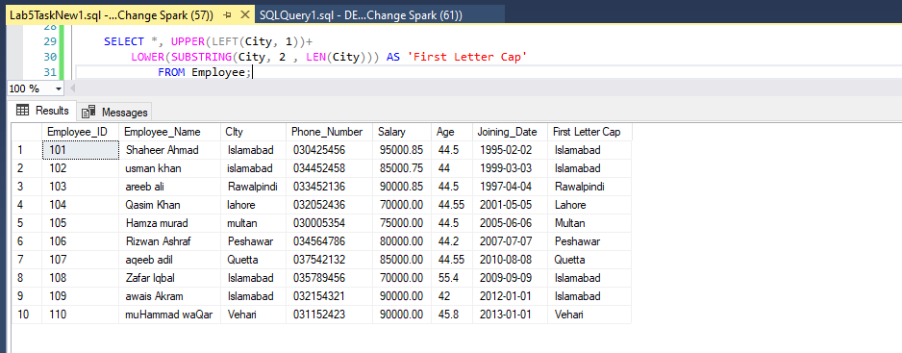

LENGTH(), CONCATE(), SUBSTRING(), REPLACE() etc
Query:
SELECT *, LEN(Employee_Name) AS 'Total Chars in Name'
FROM Employee;
Response:

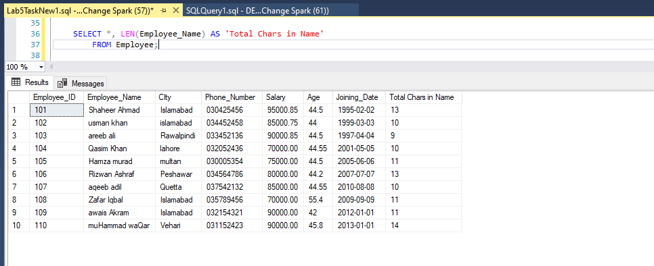
Query:
SELECT CONCAT(Employee_Name,', ', City) AS 'Name, City'
FROM Employee;
Response:
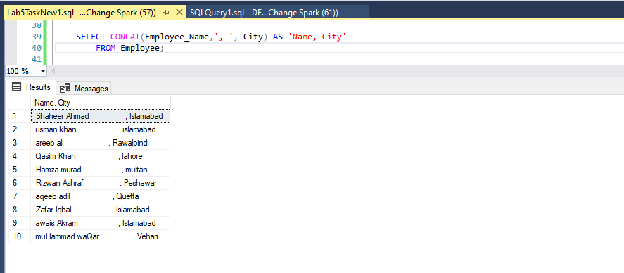

Query:
SELECT *, SUBSTRING(Employee_Name, 1, 6) AS 'Name Substring'
FROM Employee;
Response:
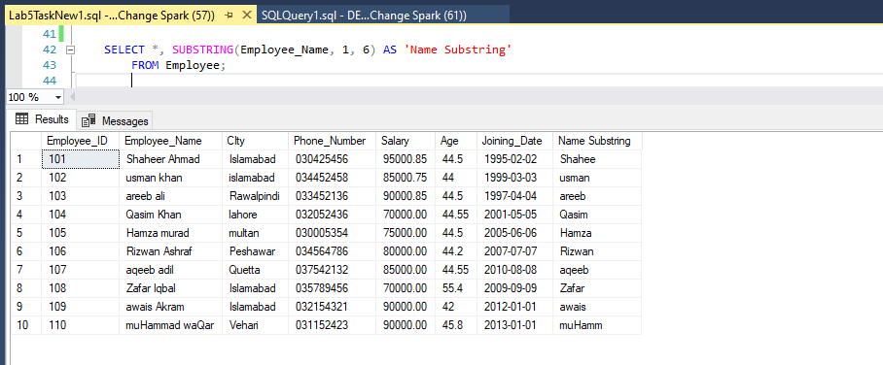
Query:
SELECT *, SUBSTRING(City, 1, 6) AS 'Name Substring'
FROM Employee;
Response:
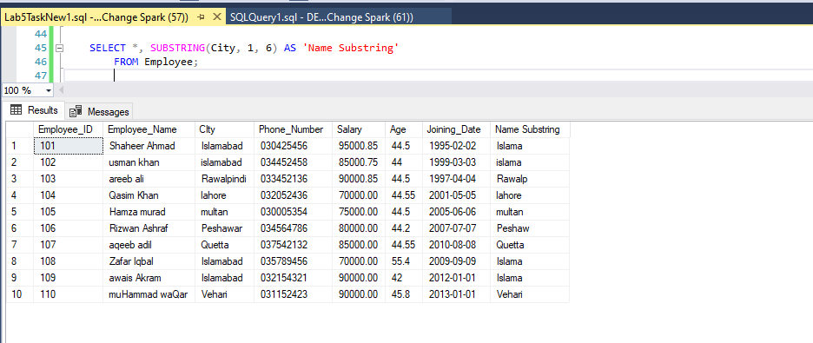
Query:
SELECT *, REPLACE(City, 'Vehari', 'quetta') AS 'New Cities'
FROM Employee;
Response:
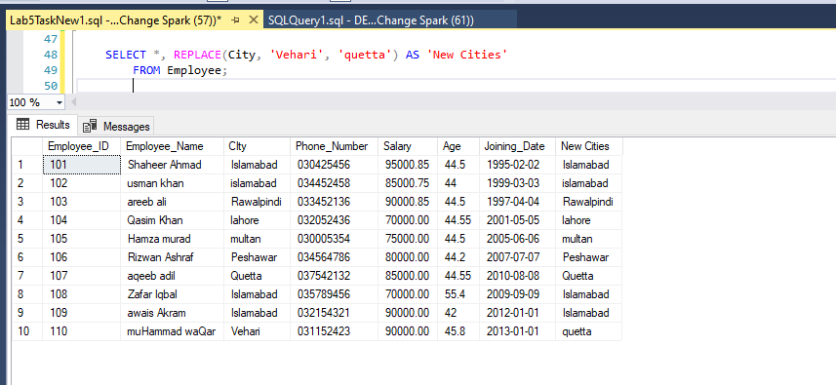
Query:
SELECT *, REPLACE(Employee_Name, 'areeb', 'sameer') AS 'New Employee Names'
FROM Employee;
Response:
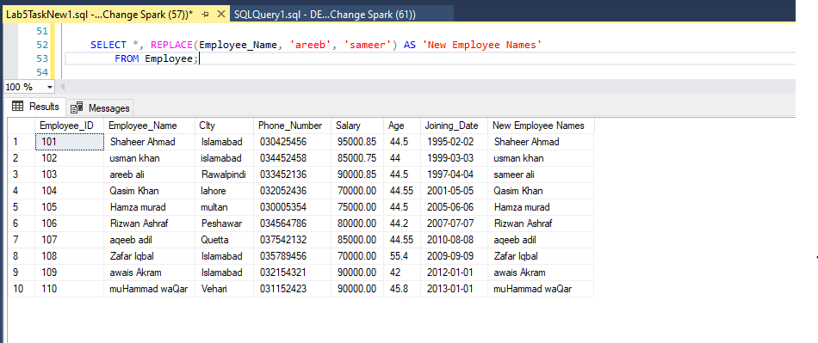
Query:
SELECT *, LTRIM(Employee_Name) AS 'Left Trimmed'
FROM Employee;
Response:
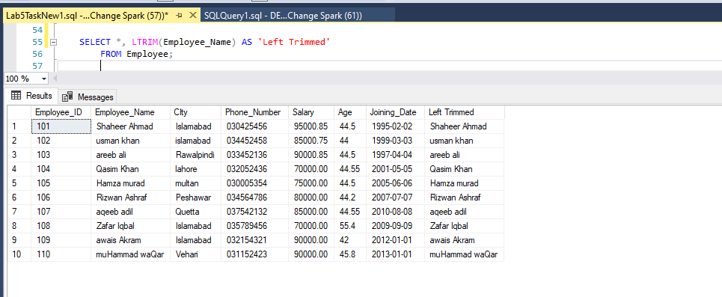
Query:
SELECT *, TRIM(Employee_Name) AS 'Trimmed'
FROM Employee;
Response:
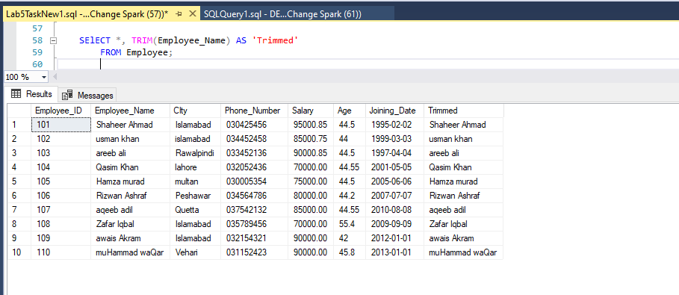
Query:
SELECT *, RTRIM(Employee_Name) AS 'Right Trimmed'
FROM Employee;
Response:
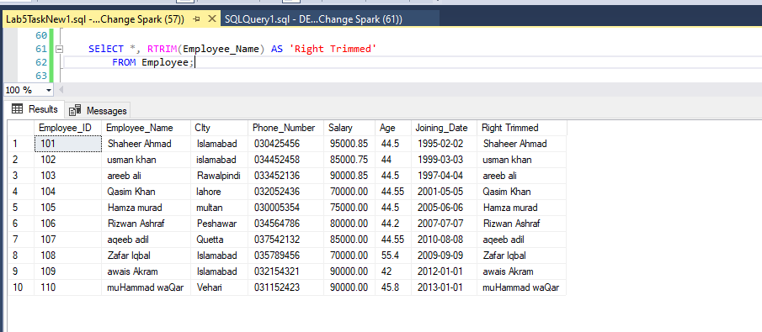
Query:
SELECT *, CHARINDEX(' ', Employee_Name) AS 'Space index in name'
FROM Employee;
Response:
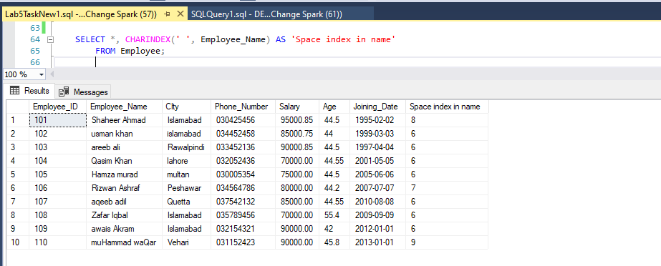

-----------------------------------------------------------------------------------------
-- Query 2: Apply different queries to get the joining date and print in different formats –-

/*
Date and Time format
1. Year
yyyy, yy
2. Month
MM, M
3. Date
dd, d
4. Hour
HH (24 hours), hh (12 hours)
5. minutes and seconds
mm, ss
*/

-----------------------------------------------------------------------------------------
Problem 2: Apply different queries to get the joining date and print in different formats
Query:
SELECT *, FORMAT(Joining_Date, 'yyyy-MM-dd') AS 'Format'
FROM Employee;
Response:
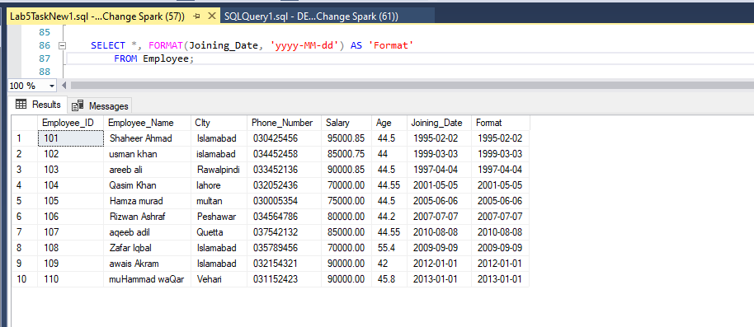
Query:
SELECT *, FORMAT(Joining_Date, 'MM-yyyy-dd') AS 'Format'
FROM Employee;
Response:
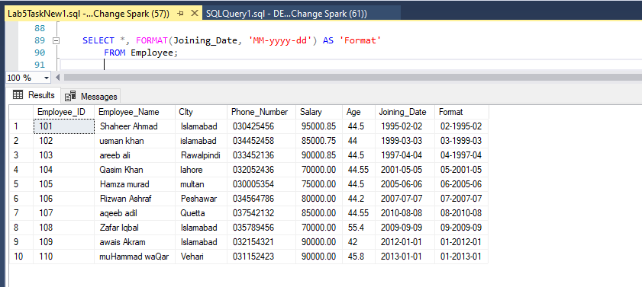
Query:
SELECT *, FORMAT(Joining_Date, 'MM-dd-yyyy') AS 'Format'
FROM Employee;
Response:
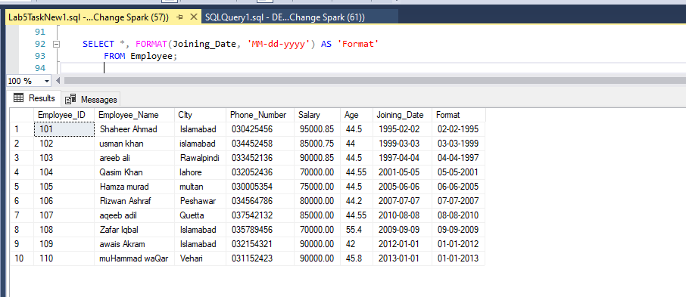
Query:
SELECT *, FORMAT(Joining_Date, 'dd-MM-yyyy') AS 'Format'
FROM Employee;
Response:
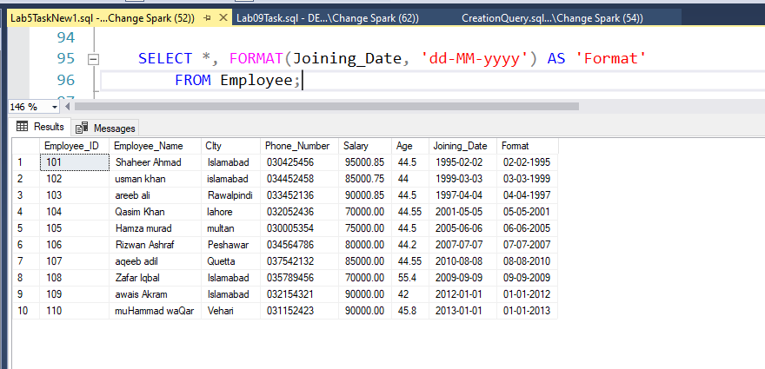
Query:
SELECT *, FORMAT(Joining_Date, 'dd-yyyy-MM') AS 'Format'
FROM Employee;

Response:
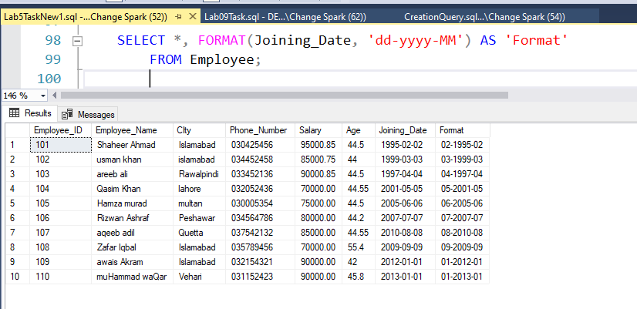
Query:
SELECT *, FORMAT(Joining_Date, 'yy-MM-dd') AS 'Format'
FROM Employee;
Response:
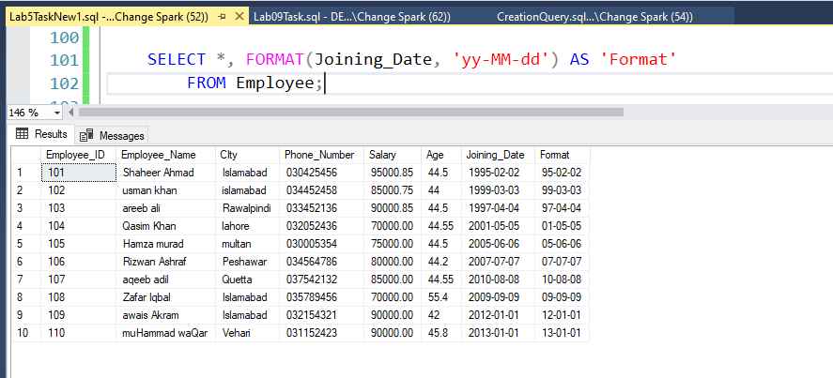
Query:

SELECT *, FORMAT(Joining_Date, 'MM-dd-yy') AS 'Format'
FROM Employee;
Response:
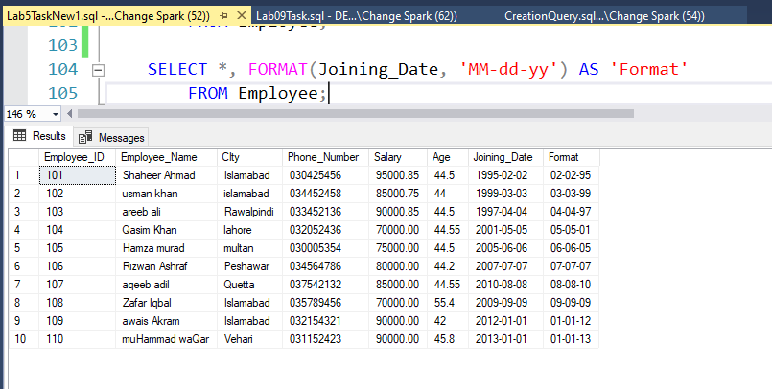
Query:
SELECT *, FORMAT(Joining_Date, 'MM-yy-dd') AS 'Format'
FROM Employee;
Response:
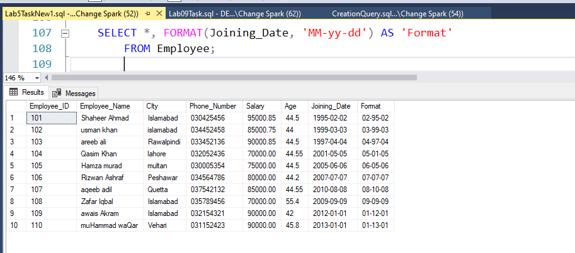

----------------------------------------------------------------------------
-- Query 3: Apply a query to print the names and joining date of all of the employees in such a way that if I have entred
-- some employee's name like "muHammad waQar" then the query should return it as Muhammad Waqar. --
---------------------------------------------------------------------------
Query:
SELECT Employee_Name,
UPPER(LEFT(Employee_Name, 1))+
LOWER(SUBSTRING(Employee_Name, 2, CHARINDEX(' ', Employee_Name)-1))+
UPPER(SUBSTRING(Employee_Name, CHARINDEX(' ', Employee_Name), 2))+
LOWER(SUBSTRING(Employee_Name, CHARINDEX(' ', Employee_Name, 3)+2, LEN(Employee_Name)))
AS 'FOrmated Employee_Name', Joining_Date
FROM Employee;
Response:
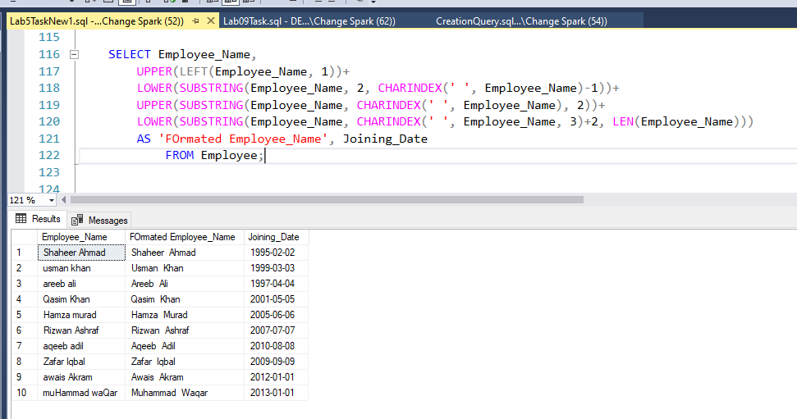

THE END

